Coding Standards
- code encoding：UTF-8
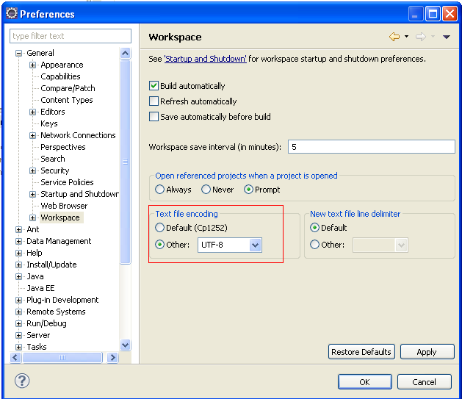

- formatter & code
code_style.xml - Window -> Preferences -> Java -> Code Style -> Clean Up -> Import
formatter.xml - Window -> Preferences -> Java -> Code Style -> Formatter -> Import
Window -> Preferences -> Java -> Editor -> Save Actions
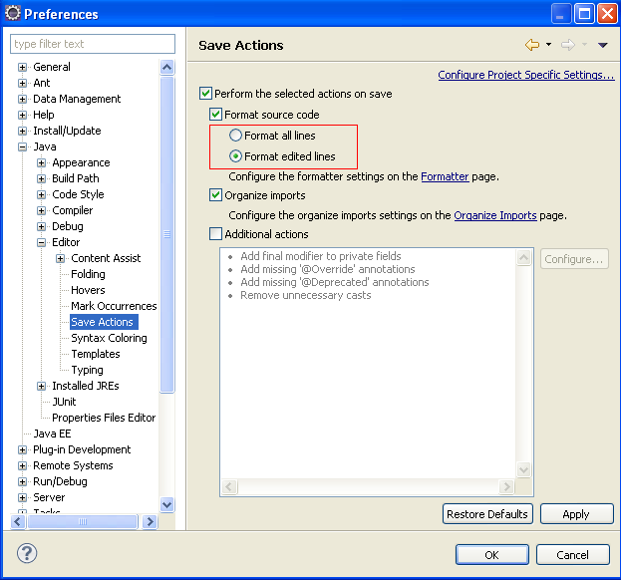

- SQLite
using the sqlite to dev first, later consider replace to derby or mysql.
sqlite: http://www.sqlite.org/
sqlite jdbc: http://www.zentus.com/sqlitejdbc/

- Log4j
log4j.properties is under the src/ folder

- Spring
- reserved

